Post Outgoing Payment (Down Payment)

S.NO. : 01- FI-AP- 03

TRANSACTION CODE : F – 53

ACCESS PATH : SAP Easy Access Accounting Financial
Accounting Accounts Payable Document
Entry Out going payment Post

We get “ Post Out Going Payment” Header data” screen ;

Required Fields:

Document date : To be entered
Account : To be entered (Vendor A/c Number)
Account Type : Default
Standard Ois : Default Ticked
Account : To be entered (Bank A/c Number
Posting date : Default
Amount : Total amount inclusive Bank Charges to be entered
Bank Charges : To be entered

Rest all other fields viz, Doc Type, Period, Companycode,Currency/Rate are default after they are entered for the first time.

We get the Screen “Post Out Going Payment - Header Data“ incorporating the above mentioned required fields as under;
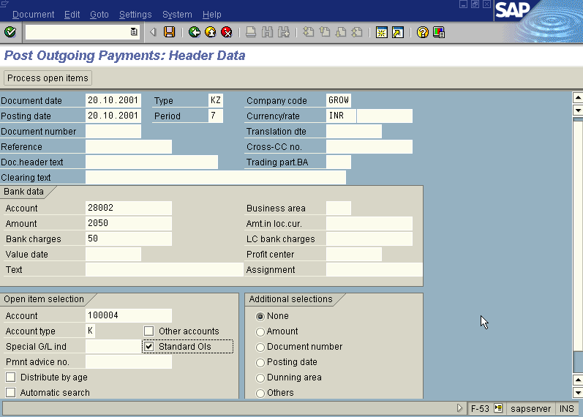

The point to be noted in the above “Post Out Going Payment - Header Data” screen is we have to leave the Spl. G/L Indicator field blank because we are clearing the Spl. G/L item down payment against the invoice.

Press button

A screen relating to the “Tax Data” will appear as under

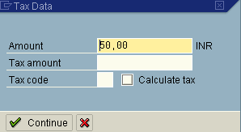

Press button

The system will display the below message

Press button

The system will display the below warning message.

Press button

Now we get “ Post Out Going Payment – Process Open Items” screen as below
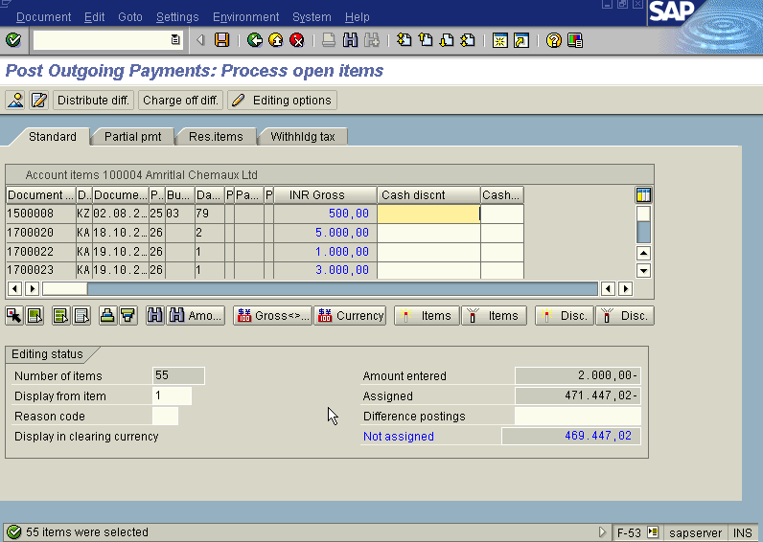

Scroll bar

In the above “ Post Out Going Payment – Process Open Items” screen

Press icon (Select all) so that all items will be highlighted in blue.

Press icon (Deactivate items) so that all items will be highlighted in blue turns to normal in black

Now use the Scroll bar on the above “ Post Out Going Payment – Process Open Items” screen till you find your Invoice on the above Screen. Then once we have found the Invoice we wanted to post, Just just double click with the mouse on the Amount field eg. 2000 in this case so the amount highlighted will turn to blue colour and the Not assigned field will turn to Zero . Here we should keep in mind that this Not assigned field has to be brought to zero to make the posting.

Press Save button

The system will display a message as under

Take a note of the document number ; 1500094

This is the stage where “Post Out Going payment” stage is complete

The document can be seen from Document Display from the top left hand side of the main screen “post out going payment - Header Data“ OR from Transaction code FB- 03 .The Document overview screen will be displayed as under showing the entries.

